Health Sense

*Note: Sub-titles are not captured in Xplore and should not be used

Kautilya Save   
Computer Science  
Pace University SeindenbergNewYork City, USA  
[kautilyasave@gmail.com](mailto:kautilyasave@gmail.com)

Kautilya Save   
Computer Science  
Pace University SeindenbergNewYork City, USA  
kautilyasave@gmail.com Kautilya Save   
Computer Science  
Pace University SeindenbergNewYork City, USA  
kautilyasave@gmail.com

Kautilya Save   
Computer Science  
Pace University SeindenbergNewYork City, USA  
kautilyasave@gmail.com Kautilya Save   
Computer Science  
Pace University SeindenbergNewYork City, USA  
kautilyasave@gmail.com

Kautilya Save   
Computer Science  
Pace University SeindenbergNewYork City, USA  
kautilyasave@gmail.com

*Abstract*—This electronic document is a “live” template and already defines the components of your paper [title, text, heads, etc.] in its style sheet. *\*CRITICAL: Do Not Use Symbols, Special Characters, Footnotes, or Math in Paper Title or Abstract*. (*Abstract*)

Keywords—component, formatting, style, styling, insert (key words)

# Introduction (*Heading 1*)

This template, modified in MS Word 2007 and saved as a “Word 97-2003 Document” for the PC, provides authors with most of the formatting specifications needed for preparing electronic versions of their papers. All standard paper components have been specified for three reasons: (1) ease of use when formatting individual papers, (2) automatic compliance to electronic requirements that facilitate the concurrent or later production of electronic products, and (3) conformity of style throughout a conference proceedings. Margins, column widths, line spacing, and type styles are built-in; examples of the type styles are provided throughout this document and are identified in italic type, within parentheses, following the example. Some components, such as multi-leveled equations, graphics, and tables are not prescribed, although the various table text styles are provided. The formatter will need to create these components, incorporating the applicable criteria that follow.

# Ease of Use

## Selecting a Template (Heading 2)

First, confirm that you have the correct template for your paper size. This template has been tailored for output on the A4 paper size. If you are using US letter-sized paper, please close this file and download the Microsoft Word, Letter file.

## Maintaining the Integrity of the Specifications

The template is used to format your paper and style the text. All margins, column widths, line spaces, and text fonts are prescribed; please do not alter them. You may note peculiarities. For example, the head margin in this template measures proportionately more than is customary. This measurement and others are deliberate, using specifications that anticipate your paper as one part of the entire proceedings, and not as an independent document. Please do not revise any of the current designations.

# PROJECT REQUIREMENTS

Below are the product requirements for making sure the project runs at optimal performance and fulfills its defined functional requirements.

## **Software Requirements**

* Browser: Mozilla Firefox 65+, Micosoft Edge, Google Chrome
* IDE: Xcode, Android Studio, Visual Studio Code
* Design: Sketch
* Assets: Adobe Photoshop, Illustrator
* Database: MySQL, Apache
* Tools:
* Version Control: Git Hosted on GitHub
* Project Management: Github Projects, JIRA, Things
* Documentation: Microsoft Word, PDF Expert

## **Hardware Requirements**

* Development
  + Apple Macbook: For iOS app development
  + Windows PC: For Android, Web & Backend development stack
* End User
  + App: Any iOS, Android device to run the app.
  + Enhanced User Experience: You could use health smart watches which would aid the end user with better usability.

## **Functional Requirements**

* The end user will be able to view his health data.
* End user could glance over the health data without installing different apps.
* User could check previous history of the specific health data
* User will get notifications on their phone and smartwatch.
* User can customize which data would be prioritized on the app screen
* User can share the health report according to their preferences.
* End user data would be secure, and the app would preserve privacy as much as possible.
* App would include biometric authentication.
* App may suggest few health tips and notify its end user pertaining to health depending on their previous history

## **Technical Requirements**

* This is a mobile application and will support iOS and Android operating system.
* This mobile application will be developed using Swift, Java and utilize MySQL database.

## **Usability Requirements**

* The mobile application will be functional on iOS 11+ devices and android 6.0+ above.
* For iOS:
  + Healthkit support on device.
  + Read/Write access to Apple Healthkit.
  + Apple Watch is necessary for watch app
  + Touch ID or Face ID is required if the user wants to have Biometric authentication
  + For Notifications, Notification access would be necessary.
* For Android:
  + LoremIPsum name is cited, such as a title or full quotation. When quotation marks are used, instead of a bold or italic typeface, to highlight a word or
  + LoremIPsum phrase, punctuation should appear outside of the quotation marks. A parenthetical phrase or statement at the end of a sentence is punctuated outside of the closing parenthesis (like this). (A parenthetical sentence is punctuated within the parentheses.)
  + LoremIPsum name is cited, such as a title or full quotation. When quotation marks are used, instead of a bold or italic typeface, to highlight a word or
  + LoremIPsum phrase, punctuation should appear outside of the quotation marks. A parenthetical phrase or statement at the end

# SYSTEM DIAGRAM

In our system diagram we would use Mobile Application communication with their internal APIs and utilize few of the core hardware functions to present the data from Operating Systems Health and fitness data store.

After the text edit has been completed, the paper is ready for the template.

## USER Use-Case

**The template is designed for, but not limited to, six authors.** A minimum of one author is required for all conference articles. Author names should be listed starting from left to right and then moving down to the next line. This is the author sequence that will be used in future citations and by indexing services. Names should not be listed in columns nor group by affiliation. Please keep your affiliations as succinct as possible (for example, do not differentiate among departments of the same organization).

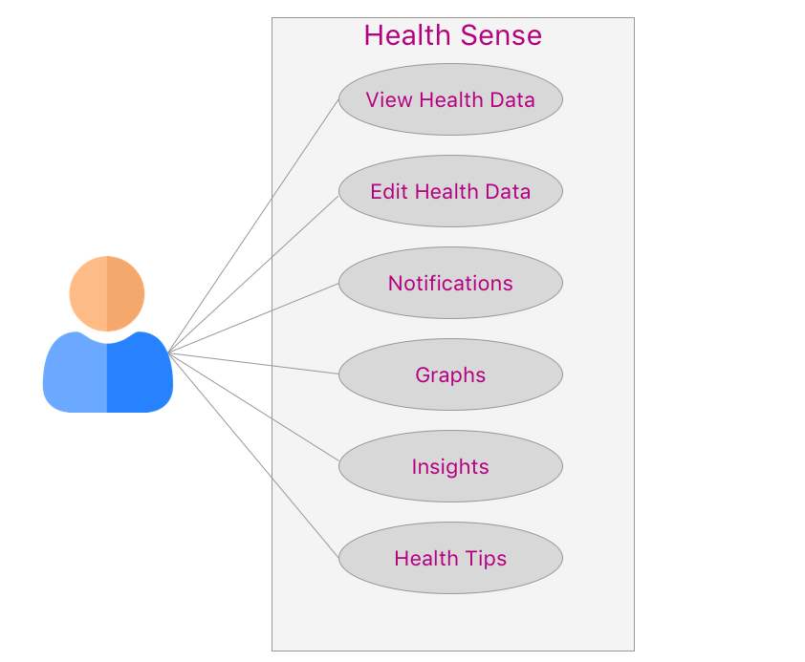

## Sequence Diagram

Headings, or heads, are organizational devices that guide the reader through your paper. There are two types: component heads and text heads.’

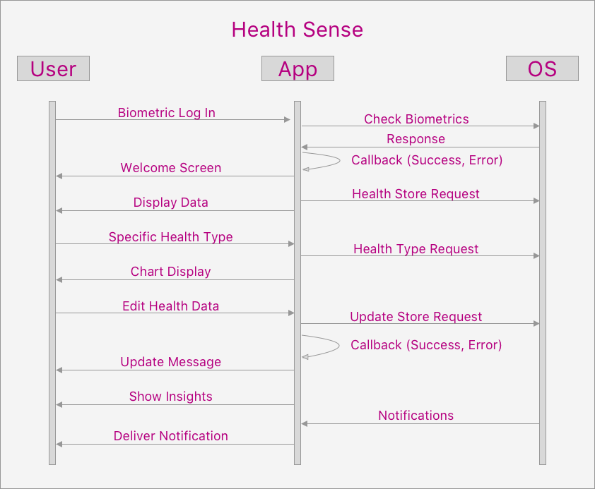

## Activity Diagram

Headings, or heads, are organizational devices that guide the reader through your paper. There are two types: component heads and text heads.’

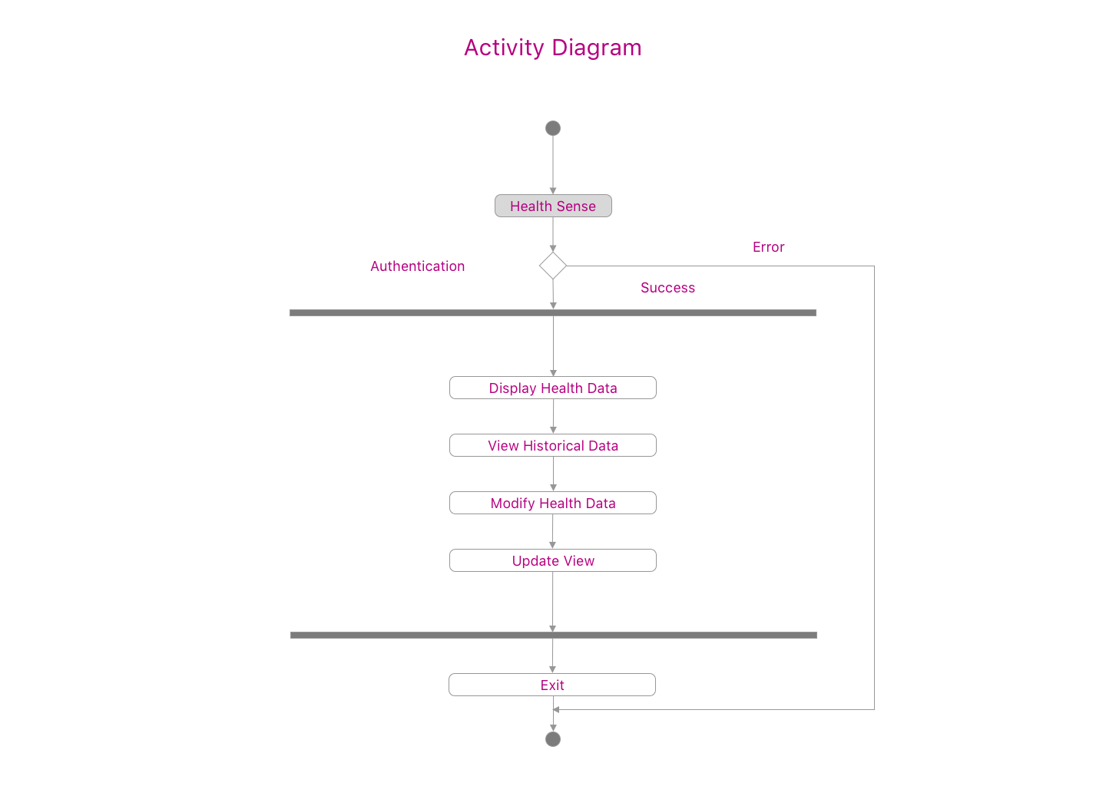

# CONCLUSION

# Summary

# Acknowledgment *(Heading 5)*

The preferred spelling of the word “acknowledgment” in America is without an “e” after the “g”. Avoid the stilted expression “one of us (R. B. G.) thanks ...”. Instead, try “R. B. G. thanks...”. Put sponsor acknowledgments in the unnumbered footnote on the first page.

# References

The template will number citations consecutively within brackets [1]. The sentence punctuation follows the bracket [2]. Refer simply to the reference number, as in [3]—do not use “Ref. [3]” or “reference [3]” except at the beginning of a sentence: “Reference [3] was the first ...”

Number footnotes separately in superscripts. Place the actual footnote at the bottom of the column in which it was cited. Do not put footnotes in the abstract or reference list. Use letters for table footnotes.

Unless there are six authors or more give all authors’ names; do not use “et al.”. Papers that have not been published, even if they have been submitted for publication, should be cited as “unpublished” [4]. Papers that have been accepted for publication should be cited as “in press” [5]. Capitalize only the first word in a paper title, except for proper nouns and element symbols.

For papers published in translation journals, please give the English citation first, followed by the original foreign-language citation [6].

1. G. Eason, B. Noble, and I. N. Sneddon, “On certain integrals of Lipschitz-Hankel type involving products of Bessel functions,” Phil. Trans. Roy. Soc. London, vol. A247, pp. 529–551, April 1955. *(references)*
2. J. Clerk Maxwell, A Treatise on Electricity and Magnetism, 3rd ed., vol. 2. Oxford: Clarendon, 1892, pp.68–73.
3. I. S. Jacobs and C. P. Bean, “Fine particles, thin films and exchange anisotropy,” in Magnetism, vol. III, G. T. Rado and H. Suhl, Eds. New York: Academic, 1963, pp. 271–350.
4. K. Elissa, “Title of paper if known,” unpublished.
5. R. Nicole, “Title of paper with only first word capitalized,” J. Name Stand. Abbrev., in press.
6. Y. Yorozu, M. Hirano, K. Oka, and Y. Tagawa, “Electron spectroscopy studies on magneto-optical media and plastic substrate interface,” IEEE Transl. J. Magn. Japan, vol. 2, pp. 740–741, August 1987 [Digests 9th Annual Conf. Magnetics Japan, p. 301, 1982].
7. M. Young, The Technical Writer’s Handbook. Mill Valley, CA: University Science, 1989.

**IEEE conference templates contain guidance text for composing and formatting conference papers. Please ensure that all template text is removed from your conference paper prior to submission to the conference. Failure to remove template text from your paper may result in your paper not being published.**